**Abstract:**

Document scanning is a daily office work  and nowadays it is used everywhere however traditional devices like flatbed scanners are not easy to carry and not available everywhere for remote work. In this paper we introduce a new document scanning application using Java and OpenCV. OpenCV is used to detect the edges of a document and then correct the perspective and rectify the image using a four point transformation method and thus return a high quality processed image and can pack the images into a pdf file.

In this work we propose a fully automatic preprocessing technique to enhance the  digital camera captured images and rectify diff type of distortion.

**Introduction:**

With the evolution in technology and the increased resolution of mobile phone cameras it has become very easy to capture images of documents using mobile phones. In addition to this the mobile phones provide the fast 3G/4G internet facility that allows the user to capture the image and use different applications to share them with each other. Also advanced technologies can be used to develop applications for this devices and easily install them in this mobile phones gives the ability to scan this documents very easily using the phone though some critical problems must be taken into consideration such as improper lighting effect and angle of capture and image warping and some more that should be effectively solved to get a comparable results to traditional scanning devices.

For Solving the problem of image warping and distortion and the potential identification of the document edges we use the libraries implementation like “Scanlibrary”  and the OpenCV.

In research’s many work has already been done on the scanning on documents using the mobile camera which mainly includes the panorama reconstruction and image mosaicing techniques given by computer vision research community.Here we are also working on to solve the perspective distortion and then allowing the user to pack the several images into a single file format like ‘.pdf’ and some other compatible formats.

**Literature Review**

***IEEE report of 2015 Rectification of Camera Captured Document Images for Camera-Based OCR Technology*** ([https://www.researchgate.net/publication/284492830](https://www.researchgate.net/publication/284492830_Rectification_of_Camera_Captured_Document_Images_for_Camera-Based_OCR_Technology)) includes different techniques of image rectification which are captured using mobile camera so that the resultant image can be further used for OCR detection. In this the three methods prescribed are Planar surface document image rectification which includes the pre-processing, text line detection, page layout detection and rectification using projective transformation. Further it talks about document rectification through text line rectification and then the 3D reconstruction of image.  
But all the methods discussed in the above paper are very slow in their processing and also do not provide a high quality result. Also many new modern techniques have been evolved and these methods are not used in current time. Also this method focuses only on image rectification and not about the add features such as image enhancement or packing of multiple images into a single file.

***Report published in the Proceedings of the 18th International Conference on Multimedia 2010, Firenze, Italy, October 25-29, 2010, Mobile Document Scanning and Copying*** ([https://www.researchgate.net/publication/221572773](https://www.researchgate.net/publication/221572773_Mobile_document_scanning_and_copying)) deals with two main degradations of perspective distortion and uneven lighting and color shift. It discusses about correcting or solving the above two critical problems using the perspective correction which includes detecting the boundary of the target document and and illumination and color correction of the image .Though it does not give the accurate result as it has the limitations that the edges of the document must be clearly identified else it will give the incorrect result and also the surface on which the document is placed must be reasonably plain and the document background must be white or brighten for proper result .therefore, this method is not suitable for the today’s advanced need.

***Mobile Phone Camera-Based Video Scanning of Paper Documents***& ***Video-Based Document Image Scanning Using a Mobile Device*** are the two reports that mainly deal with the mobile based document scanning in which the image frames are captured from a video.  In this work it has applied the method of image stitching , document shape estimation, Retinex based image enhancement,in which the frames are taken from video input and then further analysed.

**Methodology:**

In our proposed work the images scanned have the problem of perspective distortion and lightening issues also that we have to pack the complete set of images into a single sharable file like pdf. For solving this critical problem easily there are three steps that need to be fulfilled.

First we are using the open source libraries so we need to integrate them into our project.

Download the library from here <https://github.com/jhansireddy/AndroidScannerDemo>.

Place it in your project directory as shown in the screenshot.

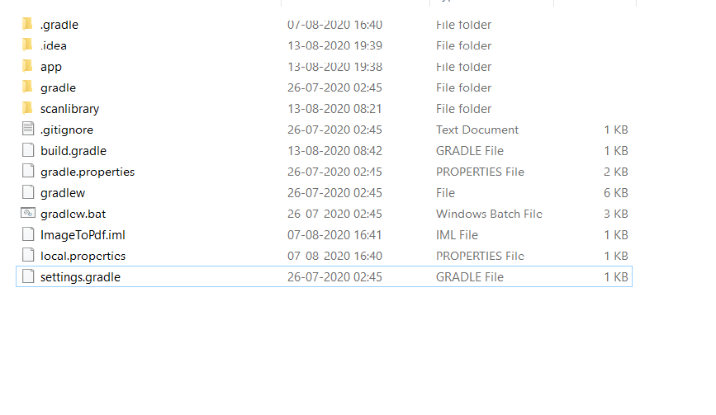

3. Open <build.gradle> and adjust SDK version with your   current project, include dependencies, change it to ‘implementation’.

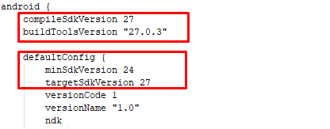

4. Go to File->New->Import Module :scanlibrary

5. 1. open setting.gradle and add library manually:

include ‘:app’, ‘:scanlibrary’

6. Include scan library in your project using implementation project(‘:scanlibrary’)

7. Then, add some permission <AndroidManifest.xml>

<uses-permission android:name=”android.permission.CAMERA” />

<uses-permission android:name=”android.permission.READ\_EXTERNAL\_STORAGE” />

<uses-permission android:name=”android.permission.WRITE\_EXTERNAL\_STORAGE” />

That’s it for integration now you can start building your document scanner. Along with this tutorial you should also check out the official documentation from the repository.

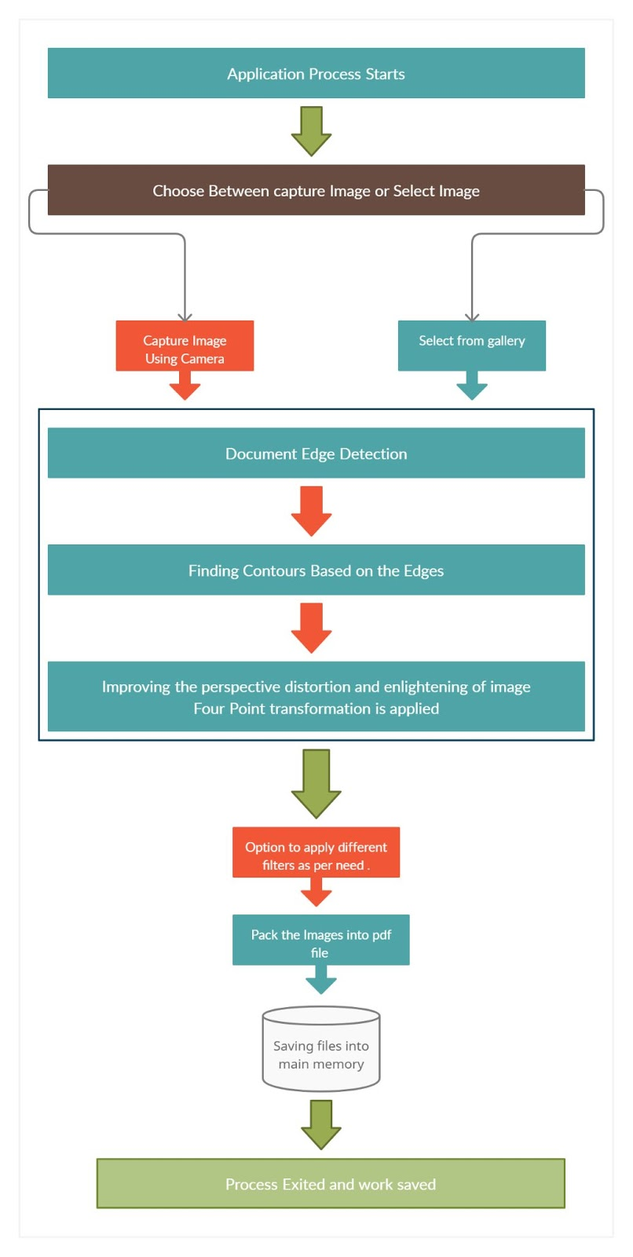

**A. Capturing Image using Camera:**

In this we will be first using the Mobile phone camera to capture the high quality document images and thus then process the images further. Here we can also select images from the gallery and send them for processing.

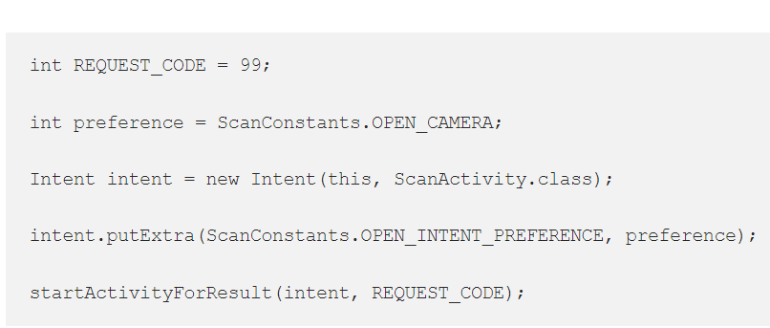

**B. Detect the edges of the document and find the contours using the image edges:**

Moving in the next step of our research work we will find the edges of the document which can be found using different detection algorithms such as canny edge detection which is one of the most popular.

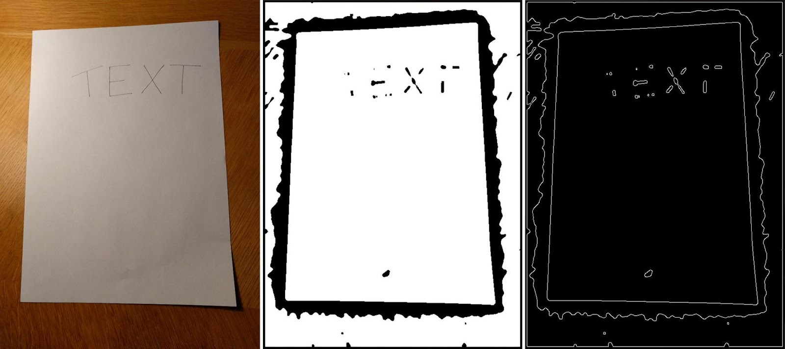

**All about Canny edge detection algorithm:**

Canny edge detector is a popular algorithm given by John F. Canny in 1986 that is used to detect the edges of any object present in an image. It uses a multi-stage algorithm for edge detection in a variety of images. Canny also advised a computational theory for this algorithm as to how it gives the best results.

It finds out the derivative of a Gaussian  and applies the filter based on it and then computes the intensity of the gradients. The noise present in the image is reduced using the gaussian. And then the potential edges are reduced upto 1 pixel curves by removing the lower value pixels of the gradient magnitude. Finally, the hysteresis thresholding is applied on the gradient magnitude with the help of which the edge pixels are either kept or removed.

The Canny’s algorithm provides the three adjustable parameters which includes:

 Width of the Gaussian (the noisier the image, the greater the width).

Low threshold for the hysteresis thresholding.

High threshold for the hysteresis thresholding.

Some basic criterias for the edge detection are:

The error rate of the edge detection should be as low as possible which means that it has accurately detected all the edges present in the image.

The position of the edge point should be accurately at the center of the edge from the operator’s view.

All the edges must be marked only once and the edges created due to noise must be avoided and necessary steps should be taken to prevent edges due to noise.

With this we will get a perfect edge of the document on which further process is to be applied i.e the four point perspective transformation and the lightning up of image and applying some filters on it.

**C. Apply a perspective transform to obtain the top-down view of the document.**

In this work of ours we are using the four point perspective top down transformation for the final image which will give us the desired output.

**About perspective transformation**: Perspective transformation is a method that is used to rectify the perspective of the image present or from the video to gather the information present in that file. Perspective transformation works by taking the points around which we want to rectify the perspective and gather the required information. Also the points around which the resultant image should be displayed must also be provided using this both sets the perspective transformation is applied and we get a resultant image.

In the same way this transformation will select the 4 points on our edge detected image and then correct its perspective angle from a top down view which will give us the brighten up image in a proper view removing most of our critical problems.

To see the output image on the screen use the below code:

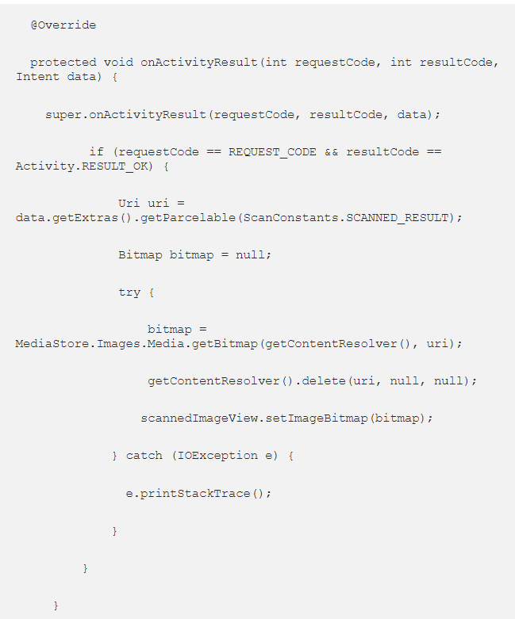

**The Process can be seen as :**

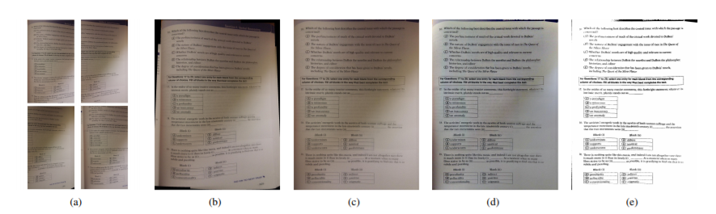

**Filters Inclusion:**

Using the predefined libraries, 4 filters have been introduced that can be implied for the special enhancement of the image which mainly includes “Black and white”, “Original”, “Magic Color” and “Gray Mode”. This will give an image a special quality and thus will equip the application with an add on feature.

**Saving the image in the main memory(database):**

**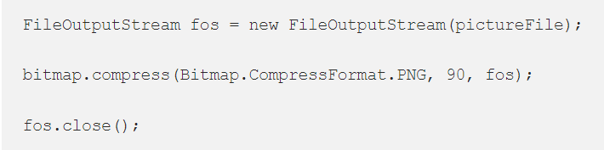**

The above lines will work for the saving of the data in the memory. Basically the bitmap image image that is received after processing and is shown on the output screen is saved in the phone memory.

**Packing up of multiple images into a single file:**

After the successful processing of the multiple images the user will have the facility of combining all the image files  into a single pdf format. For converting into a pdf file we have used the open source libraries. This pdf file can be shared using the other sharing applications.

**Implementations and Applications**

The Image scanning application can be delivered to user in many different forms, some are as follows:

It can be built in the form of a web application.

It can be implemented as an email processing server where the image is sent as an attachment and the processed image is also returned using the email service.

At last it can either be implemented as a mobile application which we have done in our work. The application captures the image using the mobile camera and then returns the processed image and shows it on the output screen. This is the most suitable and user friendly way.

**Results Discussion:**

We Implemented this application using the Android NDk and OpenCV and some open source libraries like Scanlibrary.

The representative examples are shown in Figure below. The images presented below have been captured using a Redmi Note 5 Pro (20MP). These images are the results of our scanning application.Later developments may include iOS platform and Apple iPhone support.

|  |  |  |  |
| --- | --- | --- | --- |
| IMG_264  **Original** | IMG_265  **Black n White** | IMG_266  **Grey Scale** | IMG_267  **Magic** |

|  |  |  |  |
| --- | --- | --- | --- |
| IMG_268  **Original** | IMG_269  **Black n white** | IMG_270  **Grey scale** | IMG_271  **Magic** |

Also we have shown the scanned images with the three more filters or image enhancement techniques applied on  it. The three filters which we have included are “Magic Color” , “Gray Mode” and “Black & white”.

The raw images captured using the mobile camera has a significant amount of perspective distortion although the images produced from our application as a result show significant changes and improve the quality and appearance of the image.

Although this method also possesses some limitations which includes that the image should be placed on a flat surface with a brighter background for the better results and that the boundary of the image should be clearly visible and included in the image while capturing it.

We have compared the results of our application with some of the existing systems which includes Microsoft Lens & Turbo Scan. The difference in the results can be clearly seen in the images present below, while Microsoft lens only works on the rectification of perspective transformation whereas the lighting problem is well addressed by TurboScan but is unable to deal with the problem of page warping. Our application is able to address and solve both of the above problems successfully. Also the comparison presented below successfully shows the robustness of our system in comparison to the others.

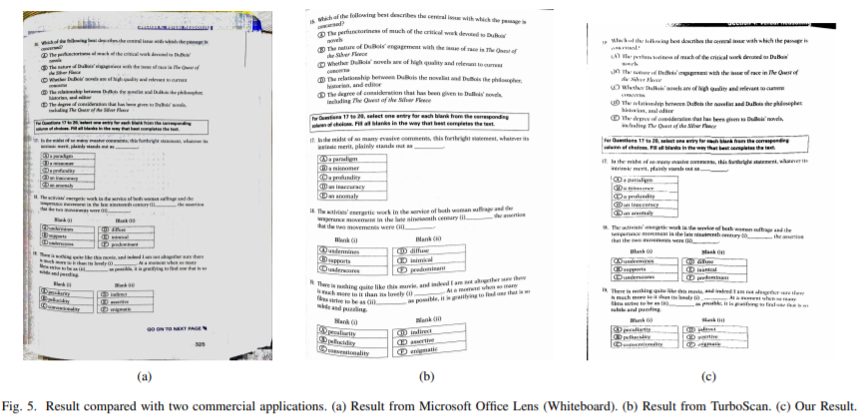

**Conclusions:**

In our work we developed an application to perform the document scanning using the mobile phone and return the high quality files that can be effectively compared with the professional scanners. We also talked about how the service can be implemented in different ways such as a Mobile client or a REST service or an Email web server. We are working on an android application that will provide the results with a higher accuracy and perform all the required functions effectively and in a more precise manner.In the future, the application proposed in this paper could be improved in several ways.

**Acknowledgement**

We as the authors would like to extend a special thanks of vote to the reviewers of this paper for their valuable suggestions to improve this paper. The paper is supported by Acropolis Institute of technology and Research, Indore.

**References:**

Bo Jiang, Sijiang Liu, Siyu Xia, Xiao Yu,Mengmeng Ding, Xuedong Hou, Yu Gao."Video-based document image scanning using a mobile device", 2015 International Conference on Image and Vision Computing New Zealand (IVCNZ), 2015.

Submitted to University of Wales Institute, Cardif.

Jian Fan, Qian Lin, Jerry Liu. "Mobile document scanning and copying" , Proceedings of the international conference on Multimedia - MM '10, 2010

Submitted to University of Newcastle upon Tyne

"Camera-Based Document Analysis and Recognition" , Springer Science and Business Media LLC, 2014.

Medium.com

Dblp.dagstuhl.de

link.springer.com

publicatio.bibl.u-szeged.hu

**Authors:**

Dhaval Maniyar, Btech CSE, Acropolis Institute of Technology & Research.

Harshit Gupta, Btech CSE, Acropolis Institute of Technology & Research.

Kartik Garg, Btech CSE, Acropolis Institute of Technology & Research.